**PROJECT REPORT**

**ON**

**PERSONAL EXPENSE TRACKER APPLICATION**

**TEAM ID:** PNT2022TMID26542

TEAM MEMBERS:

SWARNESWARAN S

AAKASH S

SRIKARTHIK S V

GOWTHAM N

**INDEX**

1. **INTRODUCTION** 
   1. Project Overview
   2. Purpose
2. **LITERATURE SURVEY**
   1. Existing problem
   2. References
   3. Problem Statement Definition
3. **IDEATION & PROPOSED SOLUTION**
   1. Empathy Map Canvas
   2. Ideation & Brainstorming
   3. Proposed Solution
   4. Problem Solution fit
4. **REQUIREMENT ANALYSIS**
   1. Functional requirement
   2. Non-Functional requirements
5. **PROJECT DESIGN**
   1. Data Flow Diagrams
   2. Solution & Technical Architecture
   3. User Stories
6. **PROJECT PLANNING & SCHEDULING**
   1. Sprint Planning & Estimation
   2. Sprint Delivery Schedule
7. **CODING & SOLUTIONING (Explain the features added in the project along with code)**
   1. Feature 1
8. **TESTING** 
   1. Test Cases
   2. User Acceptance Testing
9. **RESULTS**
   1. Performance Metrics
10. **ADVANTAGES & DISADVANTAGES**
11. **CONCLUSION**
12. **FUTURE SCOPE**
13. **APPENDIX**

Source Code

GitHub & Project Demo Link

**1. INTRODUCTION:**

**1.1 PROJECT OVERVIEW:**

This project is based on an expense and income tracking system. This project aims to create an easy, faster and smooth tracking system between the expense and the income. This project also offers some opportunities that will help the user to sustain all financial activities like digital automated diary. So, for the better expense tracking system, we developed our project that will help the users a lot. Most of the people cannot track their expenses and income one way they face a money crisis, in this case daily expense tracker can help the people to track income-expense day to day and making life tension free. Money is the most valuable portion of our daily life and without money we will not last one day on the earth. So using the daily expense tracker application is important to load a happy family. Daily expense tracker helps the user to avoid unexpected expenses and bad financial situations. This Project will save time and provide a responsible lifestyle. This system is made and supervised by the experts and satisfying by the use.

This project is based on an expense and income tracking system. This project aims to create an easy, faster and smooth tracking system between the expense and the income.This project also offers some opportunities that will help the user to sustain all financial activities like digital automated diary. So, for the better expense tracking system, we developed our project that will help the users a lot. Most of the people cannot track their expenses and income one way they face a money crisis, in this case daily expense tracker can help the people to track income-expense day to day and making life tension free. Money is the most valuable portion of our daily life and without money we will not last one day on the earth. So using the daily expense tracker application is important to load a happy family. Daily expense tracker helps the user to avoid unexpected expenses and bad financial situations. This Project will save time and provide a responsible lifestyle.

**1.2 Purpose:**

The main objective of this project is support to the user to sustain all financial activities like digital automated dairy. This application helps the user to avoid unexpected expenses and bad financial situations.

➢Using this application, users can manage all financial data and track all expense and income category wise.

➢Creating a category and recording all expenses and income under the category.

➢Enable the notification system user get notification daily at a specific time that can help the user insert expense and income.

➢Backup and Restore all information.

➢Report are generated in PDF format in category wise or time period.

**2. LITERATURE SURVEY:**

**2.1. EXISTING PROBLEM:**

After discussing our application functions and comparing them to other existing applications, some features were found lacking. This is a new application that will attract the public user through its features. There are always some challenges. We have to face some challenges as well, since the main purpose of our application is to track the user's expenses.

➢This is a windows-based application, so if a user does not have a laptop or PC then this application will not help them.

➢After getting notifications if a user doesn’t check his source for full information then the main motto of this app will fail.

**2.2. References**

[1] [http://expense-manager.com/how-expense software/](http://expense-manager.com/how-expense%20software/)

[2] <https://www.splitwise.com/terms>

[3] <http://code.google.com/p/socialauthandroid/wiki/Facebook>

[4] <http://code.google.com/p/socialauth-android>

[5] http://www.appbrain.com/app/expensemanager/ com.expensemanager

[6] https://www.xpenditure.com/en?

[7] [http://expense-manager.com/how-expense software/](http://expense-manager.com/how-expense%20software/)

[8] Donn Felker, “Android Application Development for Dummies”, published by For Dummies, 2010.

**2.3. Problem Statement Definition:**

Many organizations have their own system to record their income and expenses, which they feel is the main key point of their business progress. It is good habit for a person to record daily expenses and earning but due to unawareness and lack of proper applications to suit their privacy, lacking decision making capacity people are using traditional note keeping methods to do so. Due to lack of a complete tracking system, there is a 2 constant overload to rely on the daily entry of the expenditure and total estimation till the end of the month.

| Who does the problem affect? | People getting regular wages. |
| --- | --- |
| What is the issue? | The paper based expense tracker system does not provide the user portability , existing system only used on paper based records so unable to update anywhere expenses done and unable to update the location of the expense details disruptive that the proposed system. |
| When does the issue occurs? | When the digits could not be recognized correctly. When the transactions are not successful. When the elder people unable to understand the smaller handwritten digits. When the paper based expense tracker records are subjected to fire accident, flood, etc. |
| Where is the issue occurring? | The issue occurs when the person is unable to  track his income and expenditure. |
| Why is it important that we fix theproblem? | By solving this issue those people getting regular wages can track their expenses and  avoid unwanted expenses. |

**3. IDEATION & PROPOSED SOLUTION**

**3.1Empathy Map Canvas**

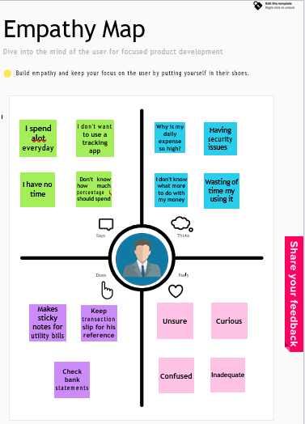

**3.2 Ideation & Brainstorming**

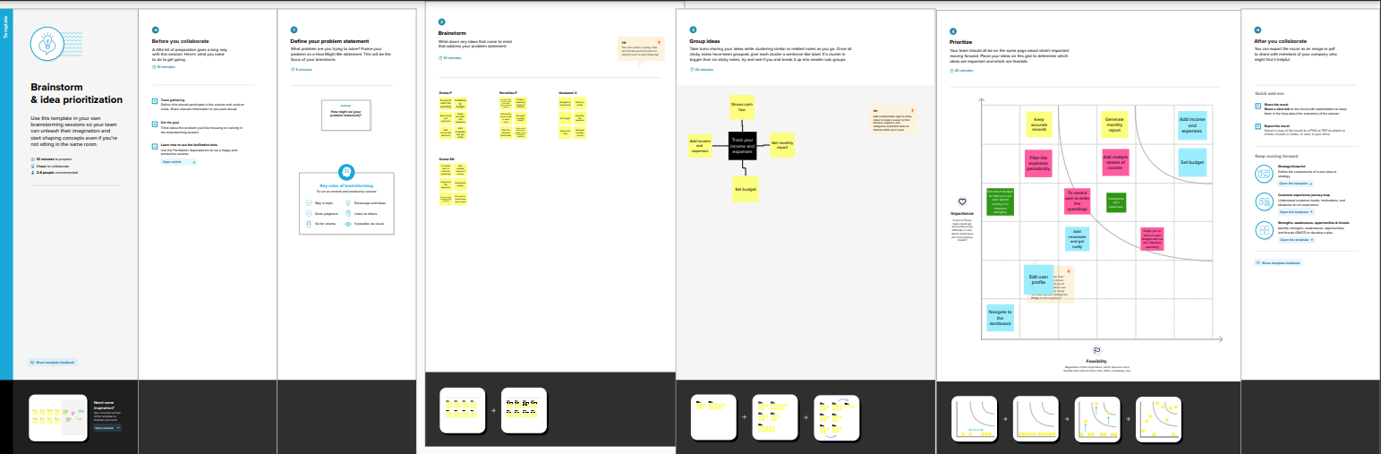

* 1. **Proposed Solution**

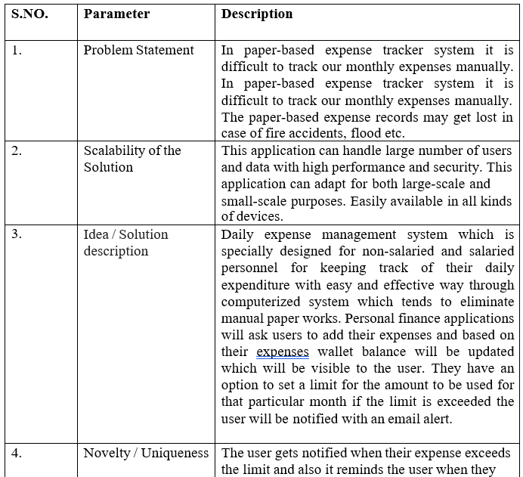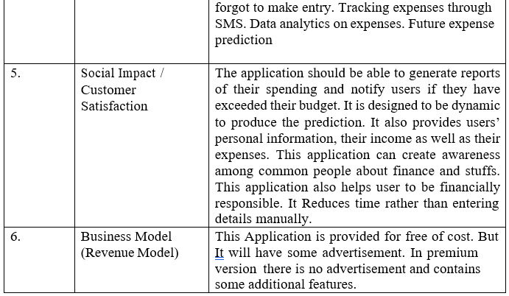

* 1. **Problem Solution Fit**

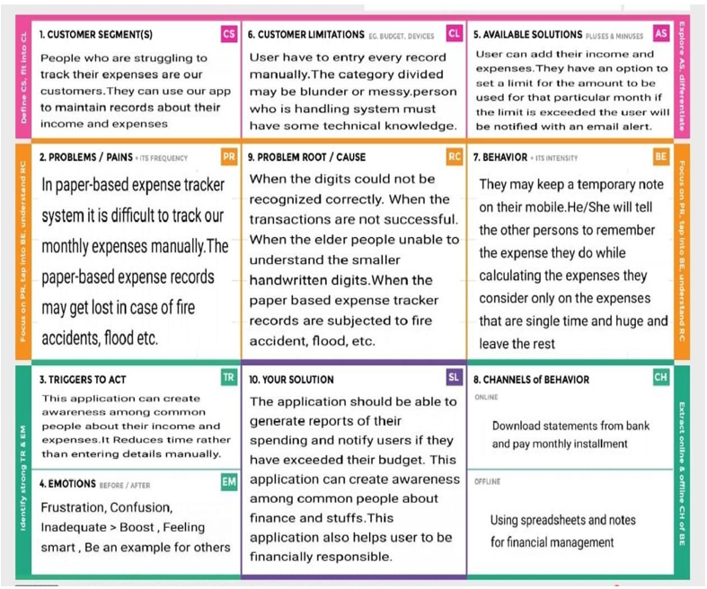

**4. REQUIREMENT ANALYSIS**

* 1. **Functional requirement**

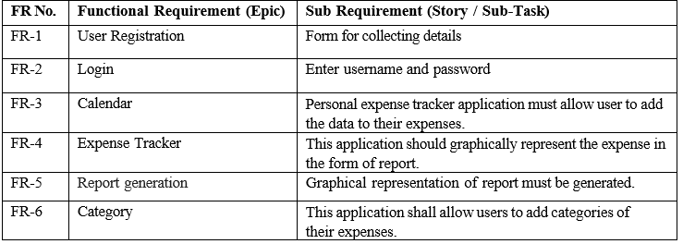

**14.2Non-Functional requirements**

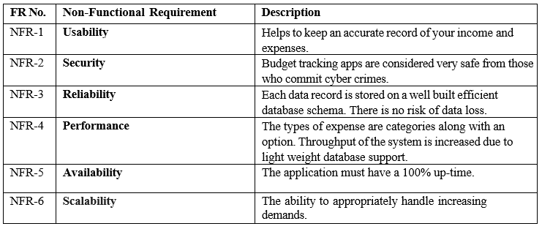

1. **PROJECT DESIGN**
   1. **Data Flow Diagram**

A Data Flow Diagram (DFD) is a traditional visual representation of the information flows within a system. A neat and clear DFD can depict the right amount of the system requirement graphically. It shows how data enters and leaves the system, what changes the information, and where data is stored.

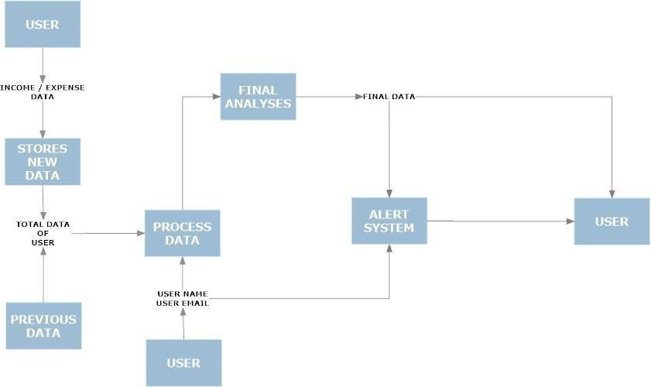

* 1. **Solution & Technical Architecture**

**Solution Architecture:**

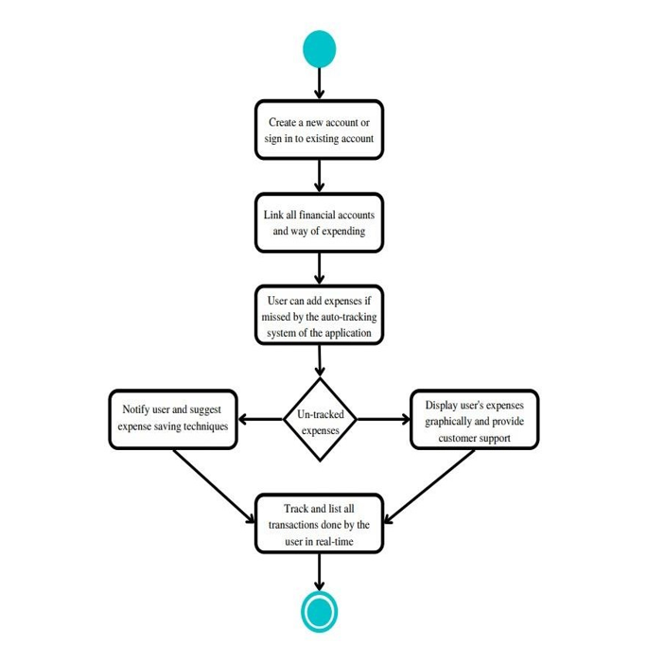

**Technical Architecture:**

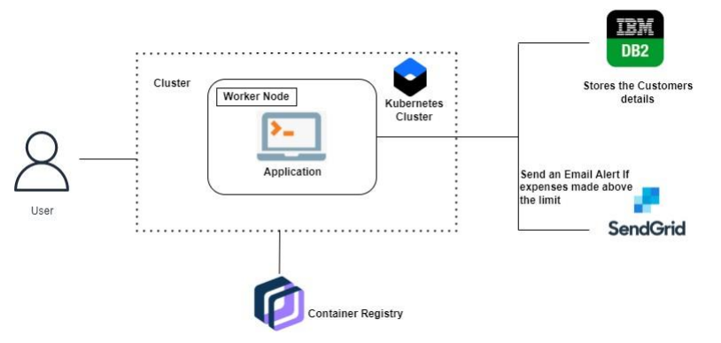

**5.3User Stories:**

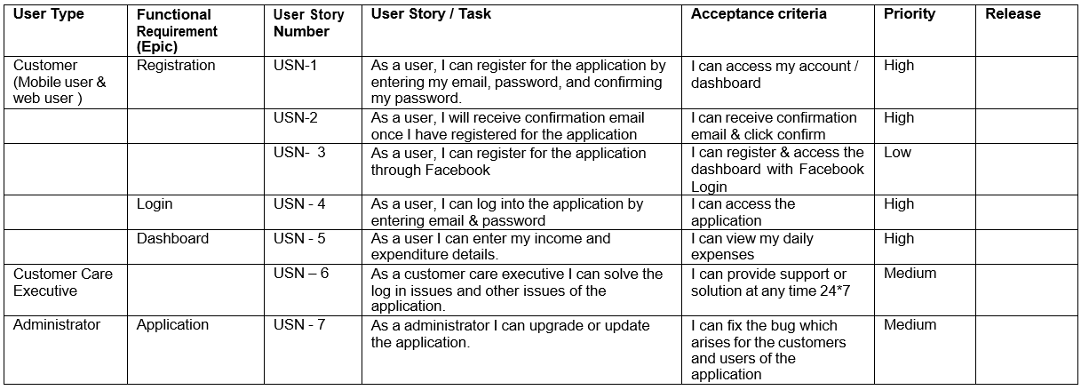

1. **PROJECT PLANNING & SCHEDULING**
   1. **Sprint Planning & Estimation & Scheduling:**

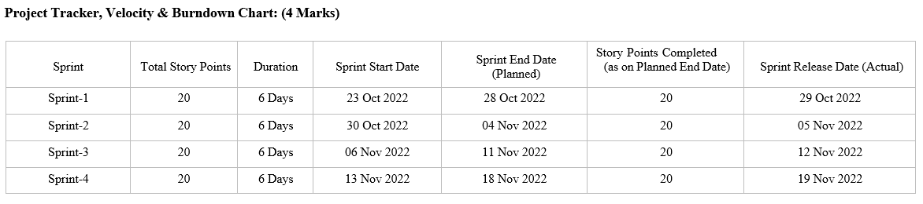

**7.CODING & SOLUTIONING**

**(Explain the features added in the project along with code)**

**7.1 Feature 1:**

**Home:**

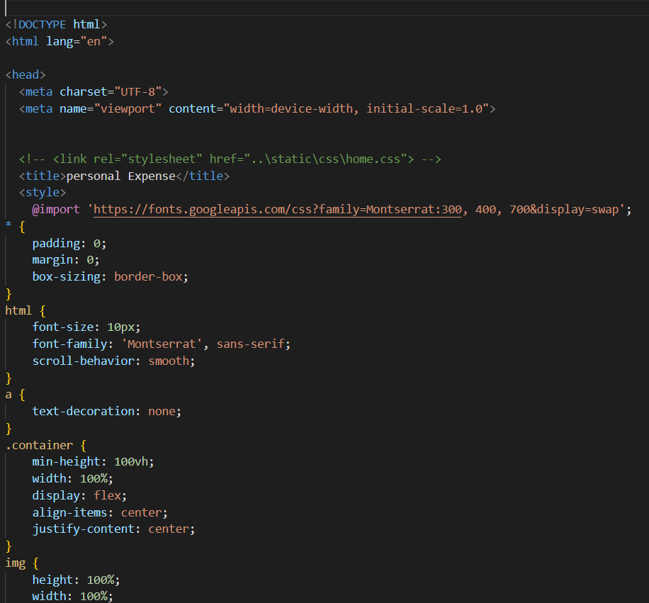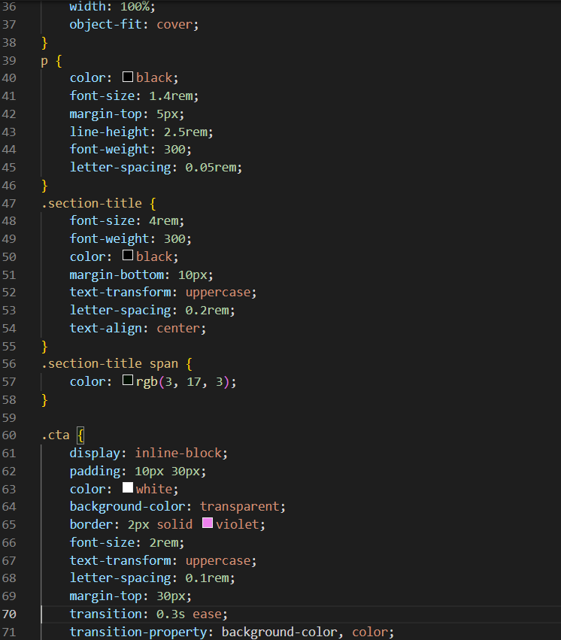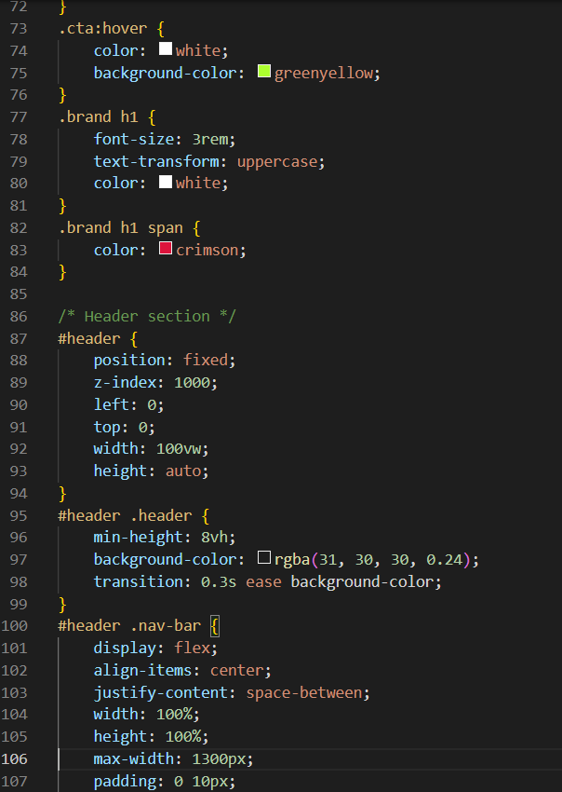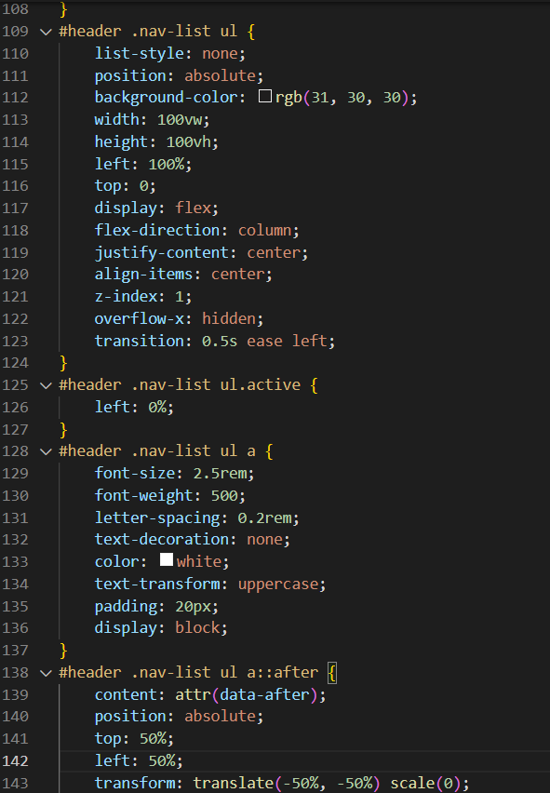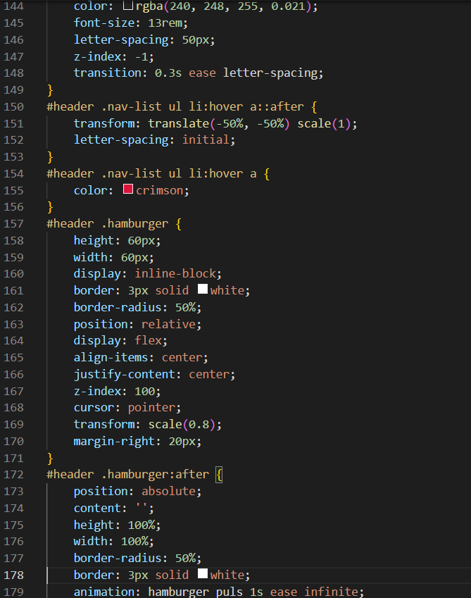

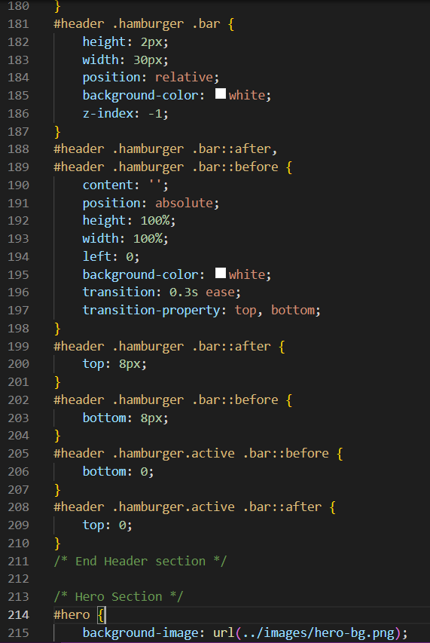

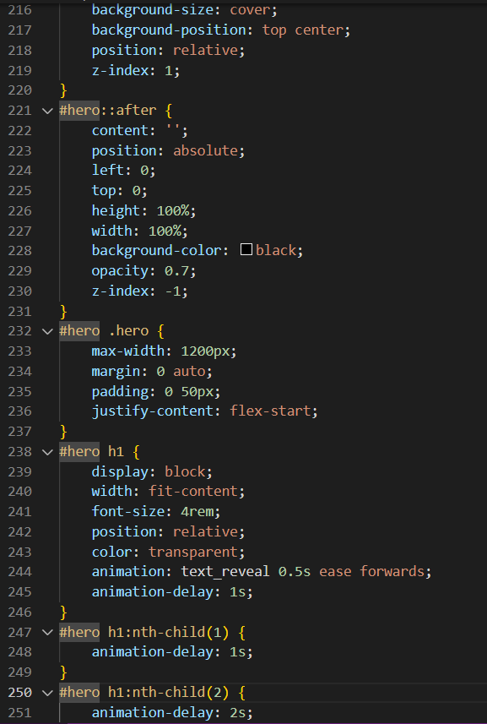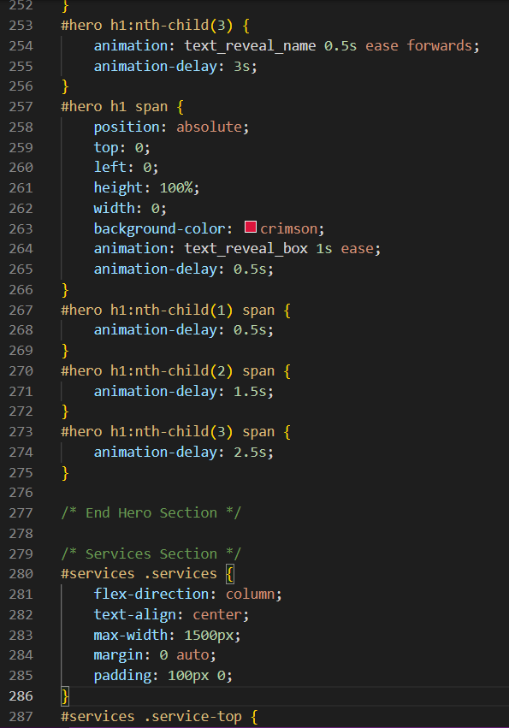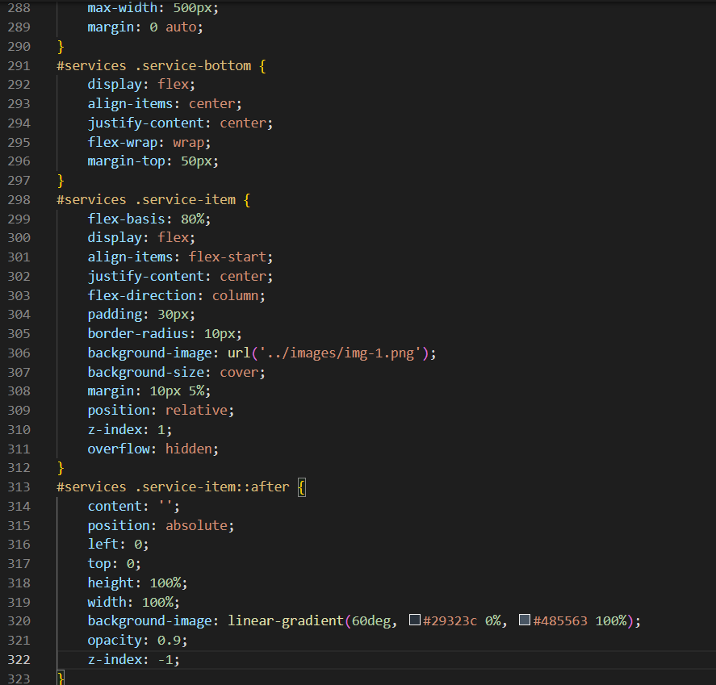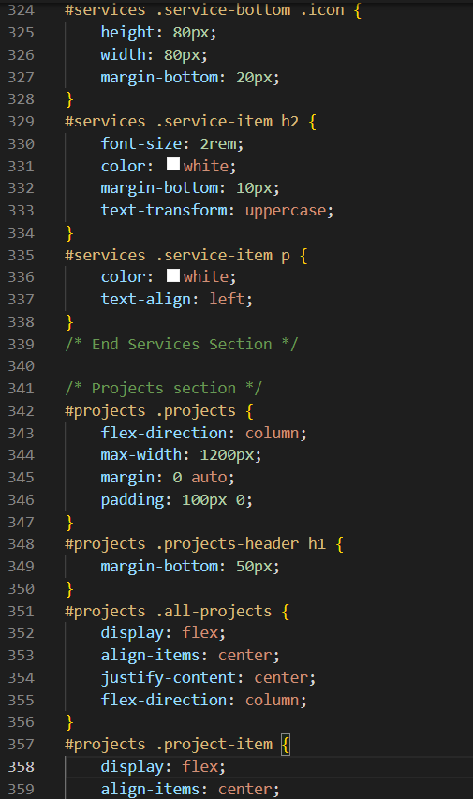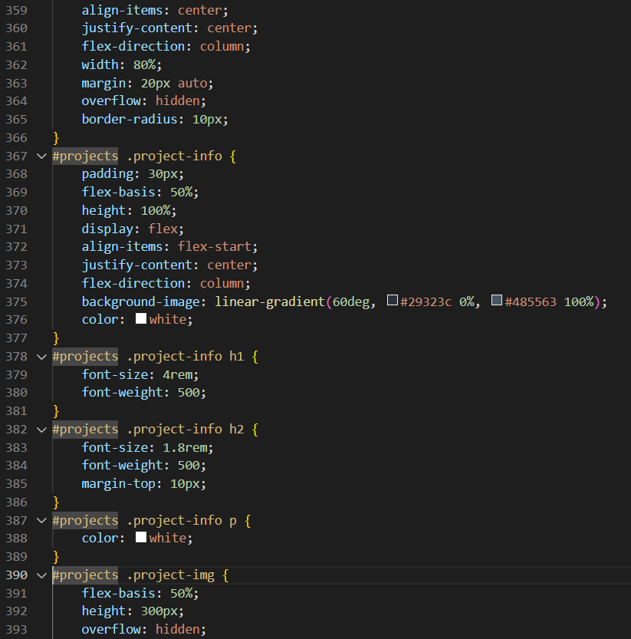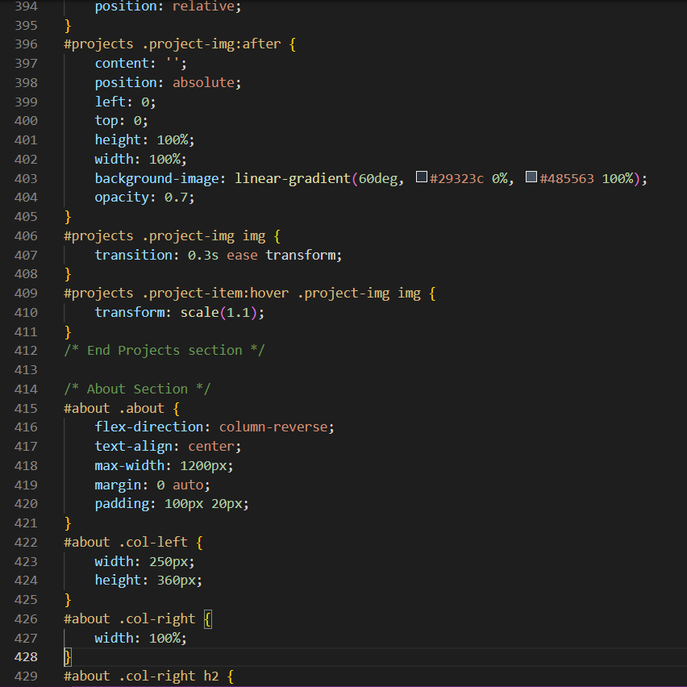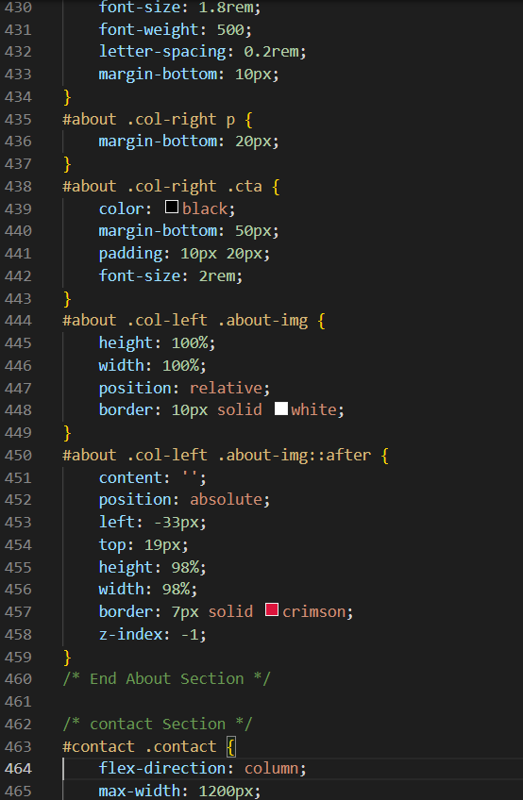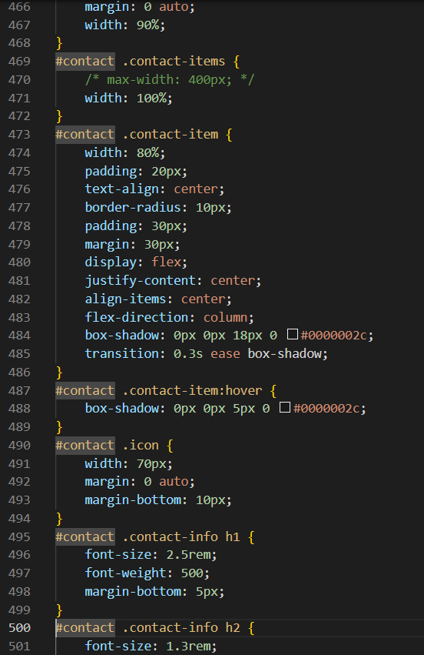

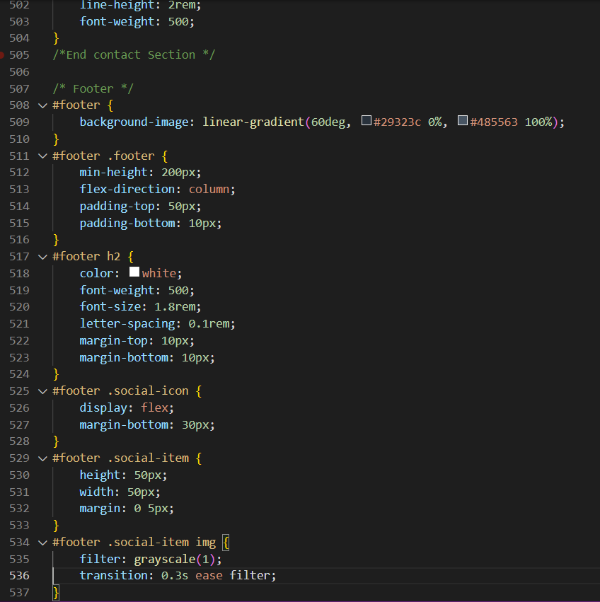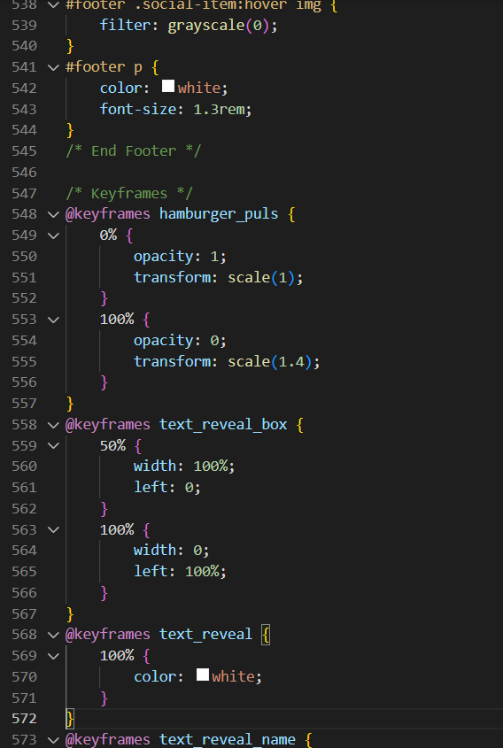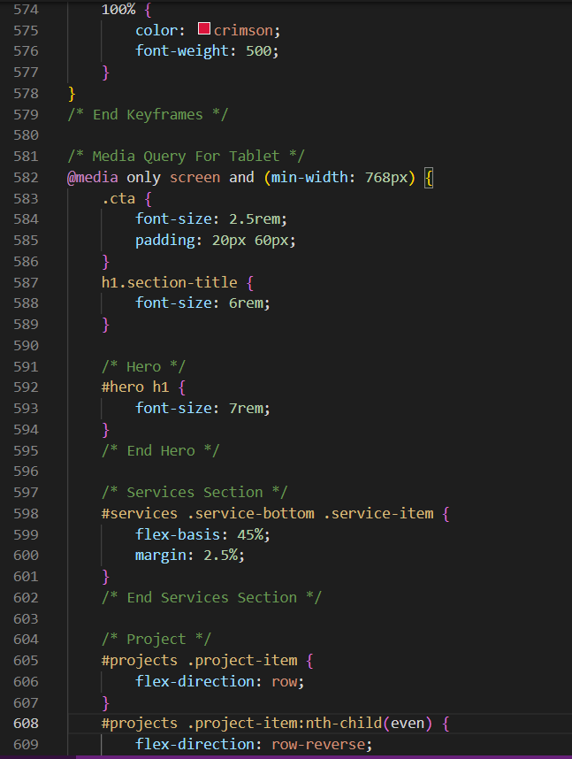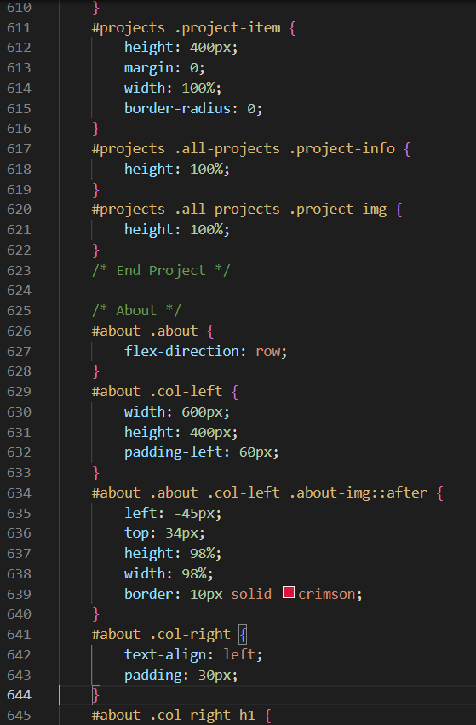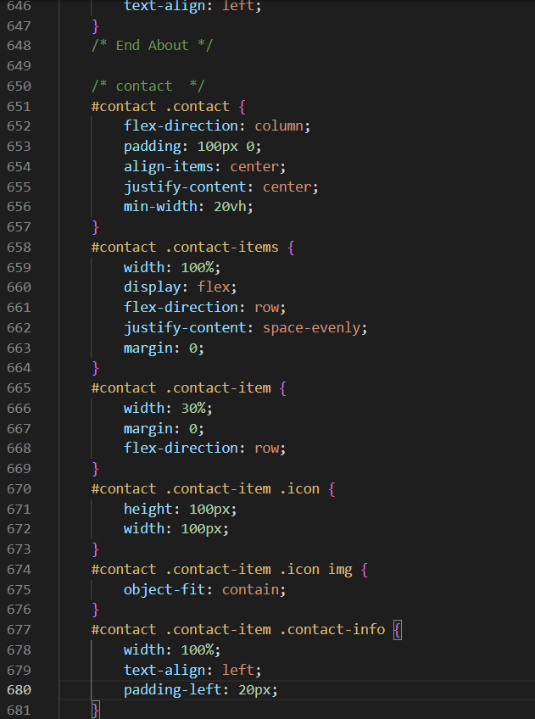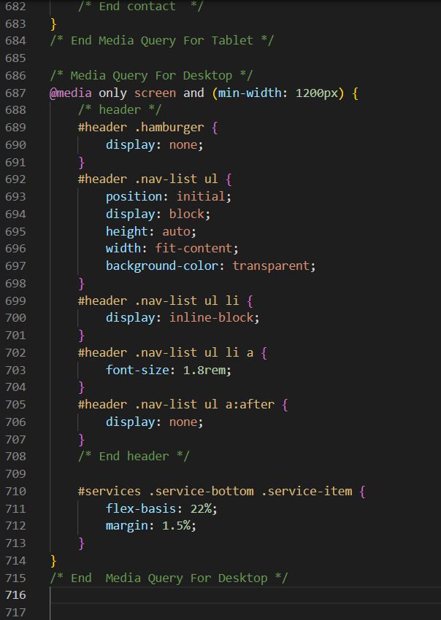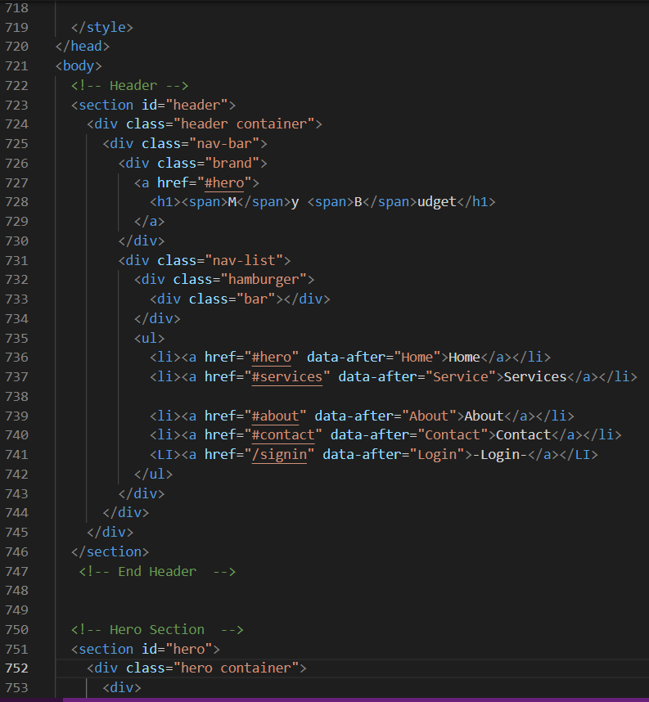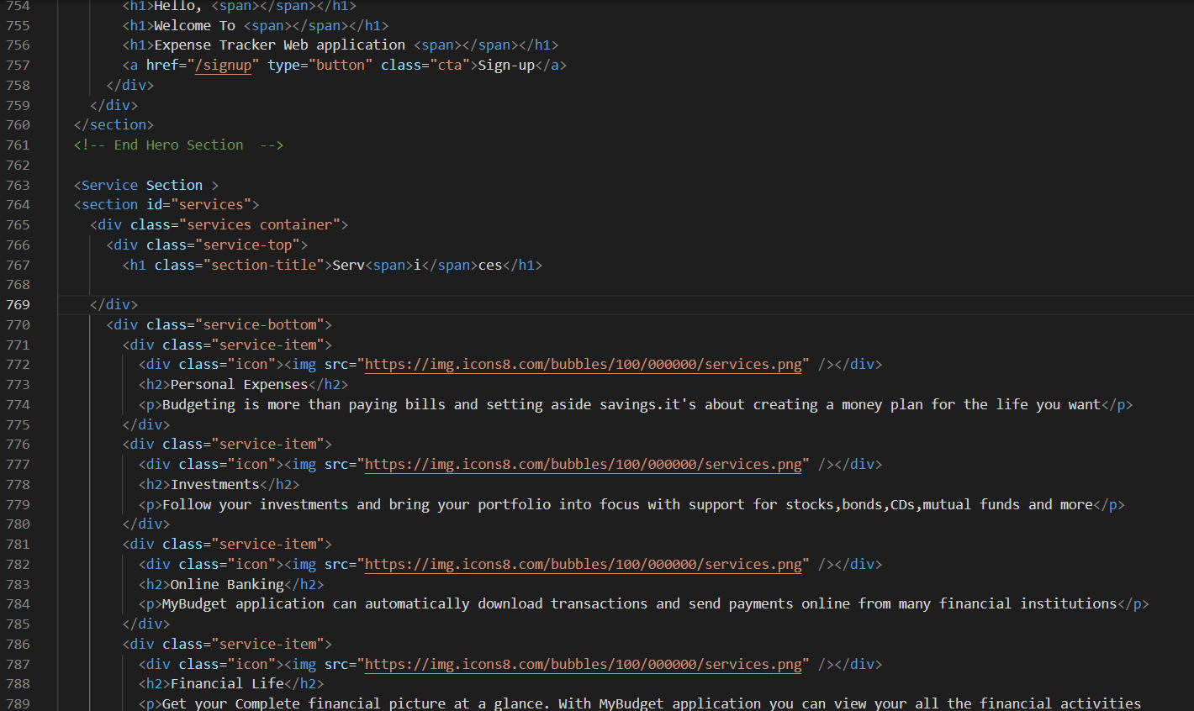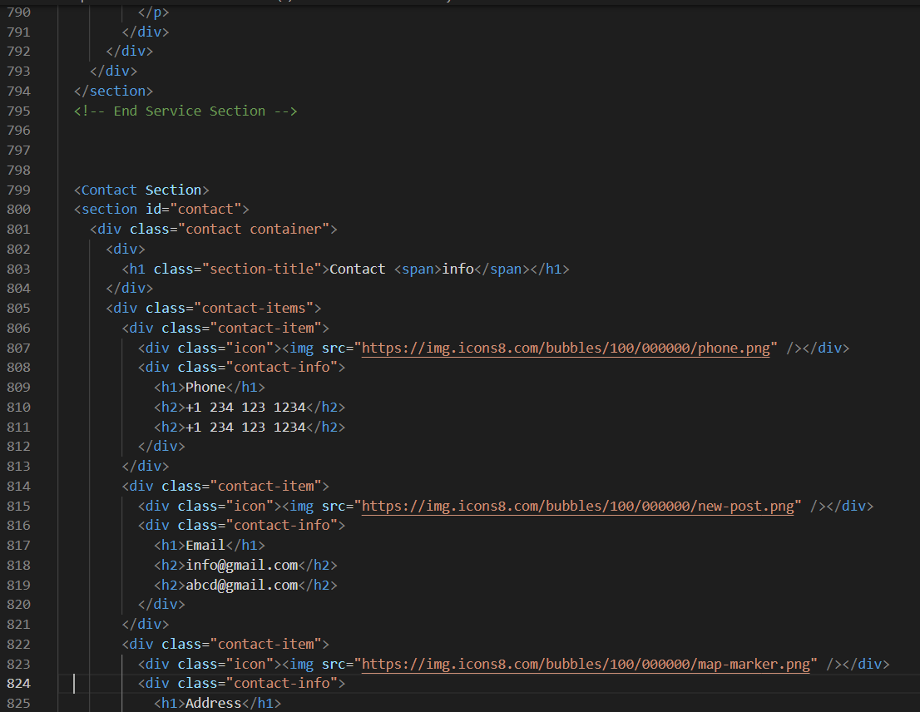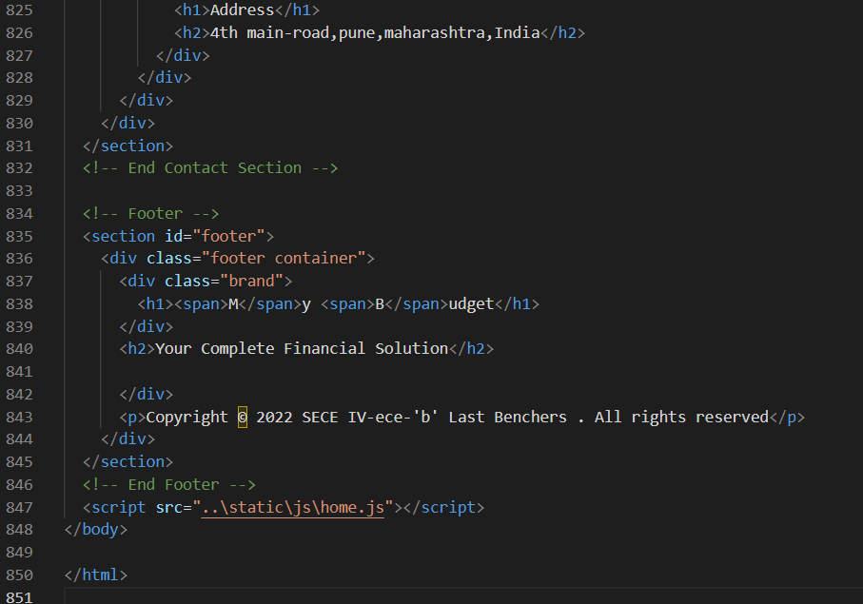

**7.2 Feature 2:**

**Homepage:**

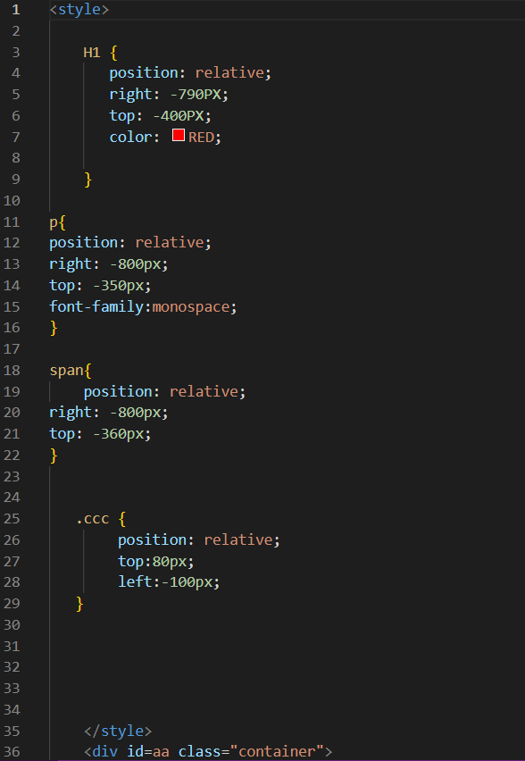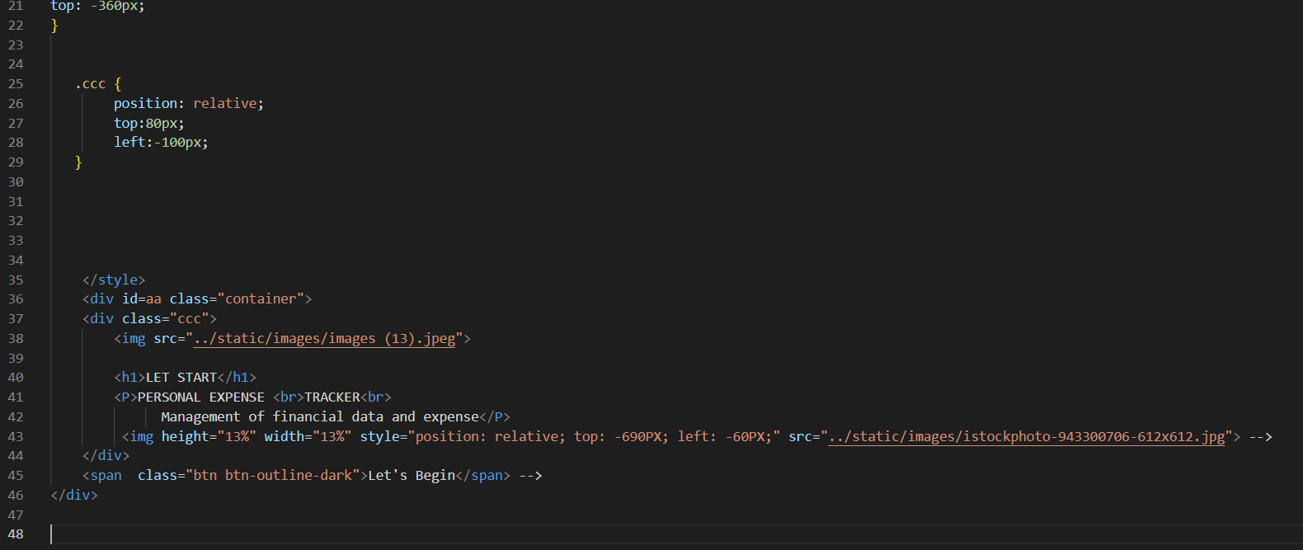

**8.TESTING**

**8.1 User acceptance testing:**

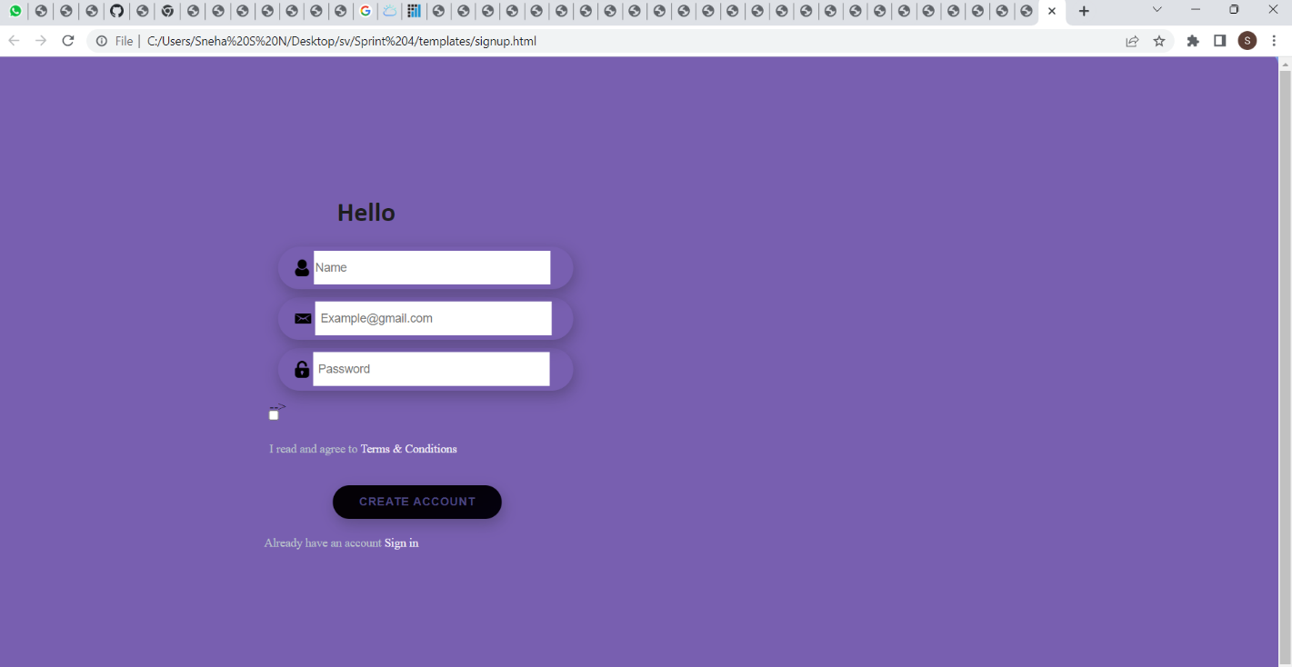

**9.RESULTS**

**9.1Performance Metrics:**

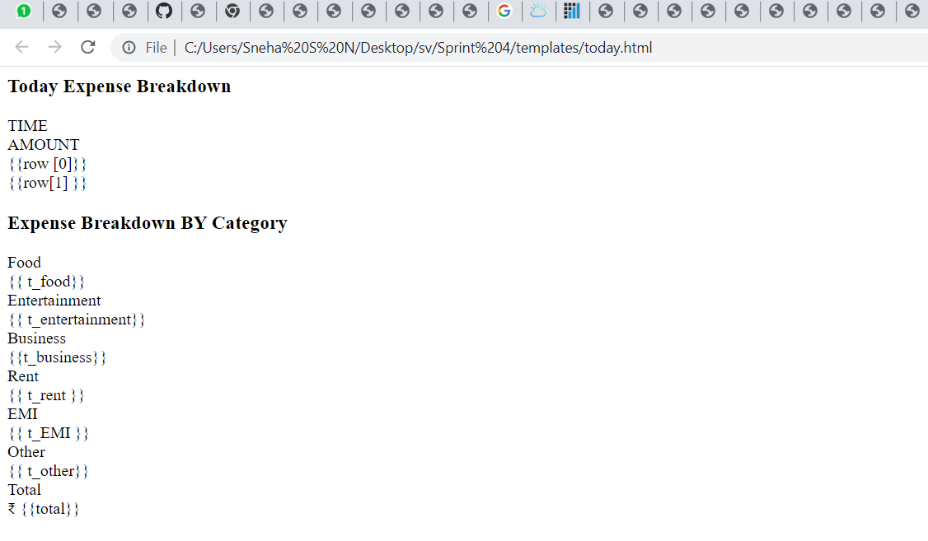

**10. ADVANTAGES AND DISADVANTAGES**

**Advantages:**

* **Easy to handle**
* **We can be aware of our expenses**
* **Budget friendly**
* **Easy access**
* **Faster**
* **It saves time**

**Disadvantages:**

* **Internet connectivity**

**11. CONCLUSION:**

After making this application we assure that this application will help its

users to manage the cost of their daily expenditure. It will guide them and make them

aware about their daily expenses. It will prove to be helpful for the people who are

frustrated with their daily budget management, irritated because of the amount of

expenses and wish to manage money and to preserve the record of their daily cost

which may be useful to change their way of spending money. In short, this application

will help its users to overcome the wastage of money.

Monitoring your everyday expenses can set aside you cash, yet it can likewise help you set your monetary objectives for what’s to come. On the off chance that you know precisely where your sum is going much of a stretch see where a few reductions and bargains can be made. Expense Tracker project is for keeping our day-to-day expenditures will helps us to keep record of our money daily. The project what we have created is work more proficient than the other income and expense tracker. The project effectively keeps away from the manual figuring for trying not to ascertain the pay and cost each month. It’s a user-friendly application.

**12. FUTURE SCOPE:**

1) It will have various options to keep record (for example Food, Travelling Fuel, Salary etc. 2) Automatically it will keep on sending notifications for our daily expenditure.

3) In today’s busy and expensive life, we are in a great rush to make moneys, but at the end of the month we broke off. As we are unknowingly spending money on title and unwanted things. So, we have come over with the plan to follow our profit.

4) Here user can define their own categories for expense type like food, clothing, rent and bills where they have to enter the money that has been spend and likewise can add some data in extra data to indicate the expense.

**13.APPENDIX**

**Source Code:**

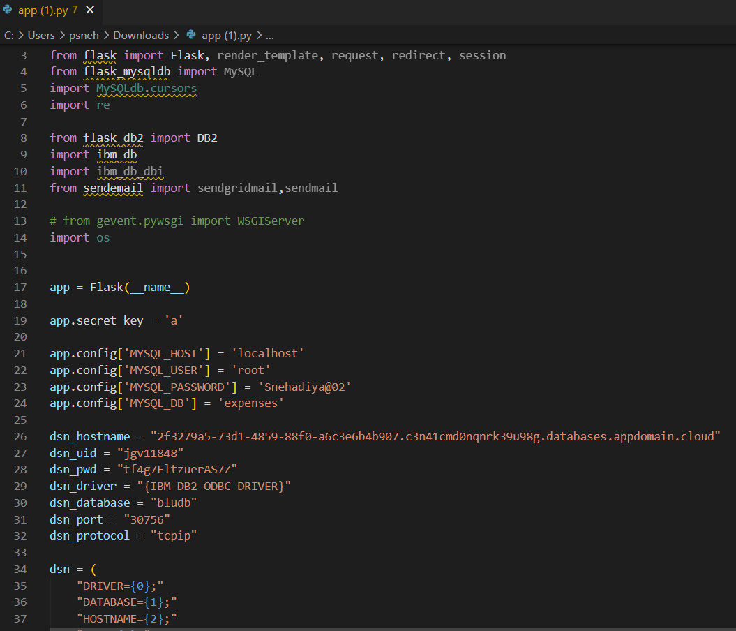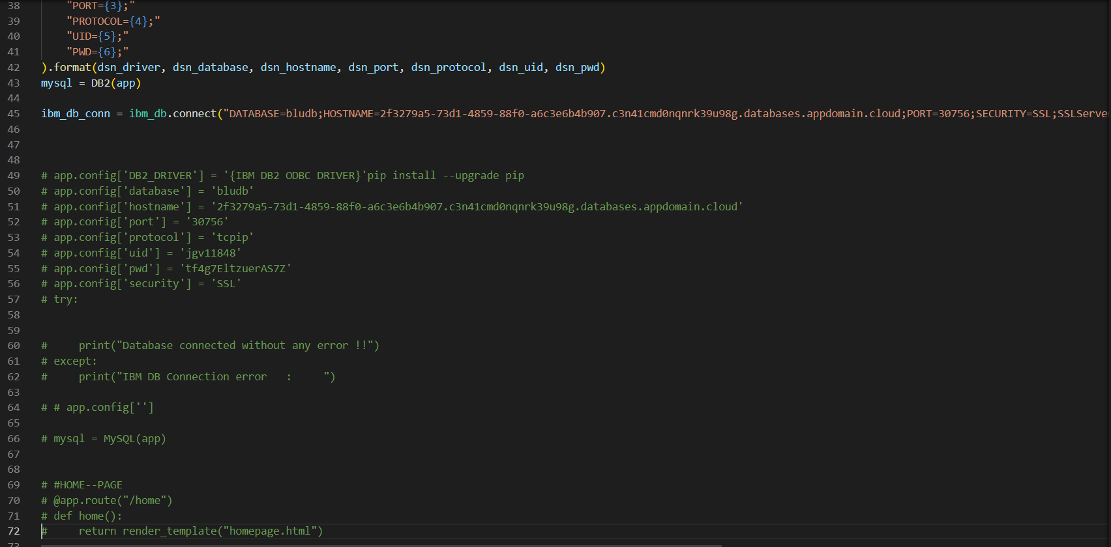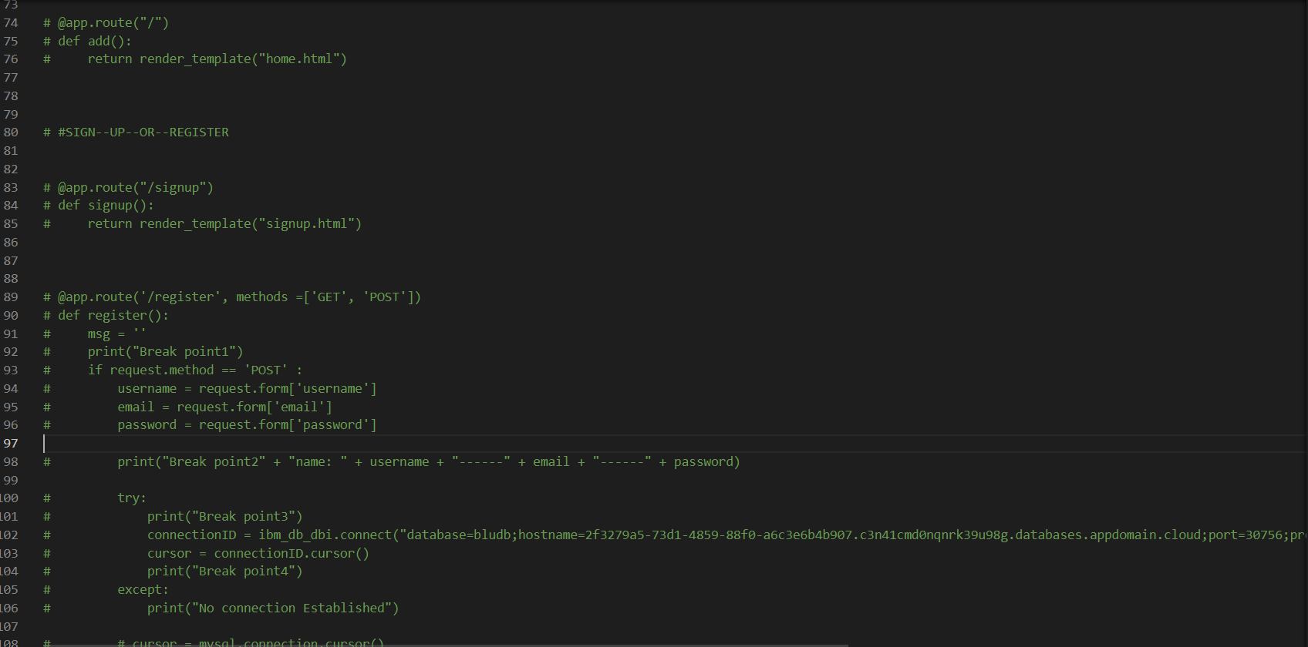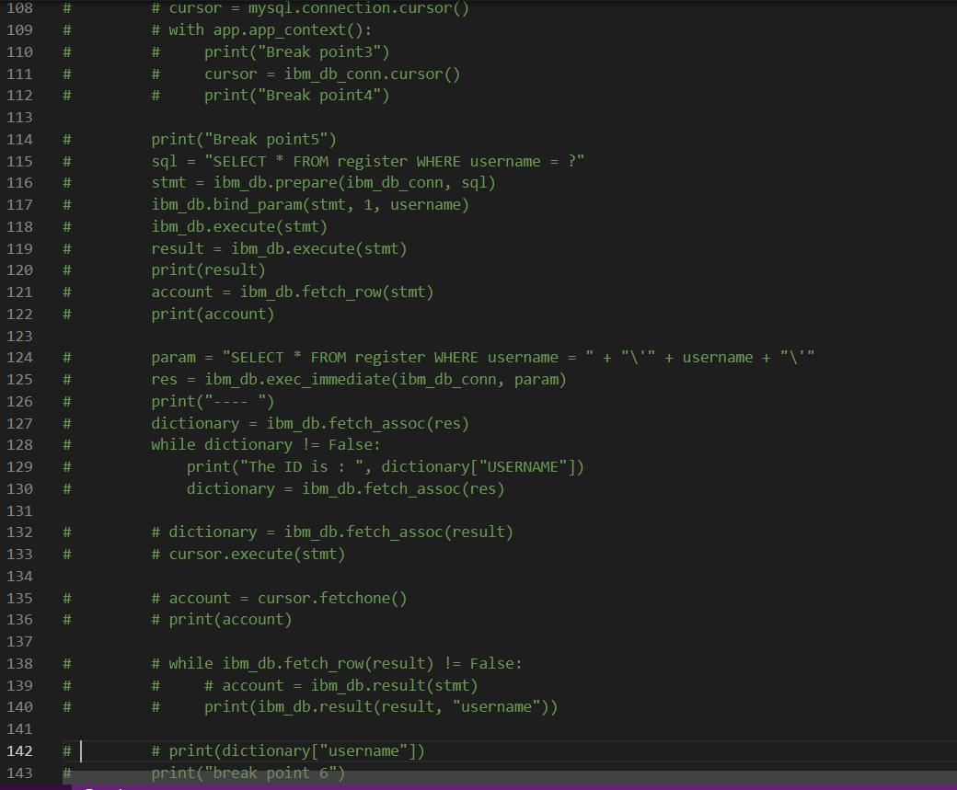

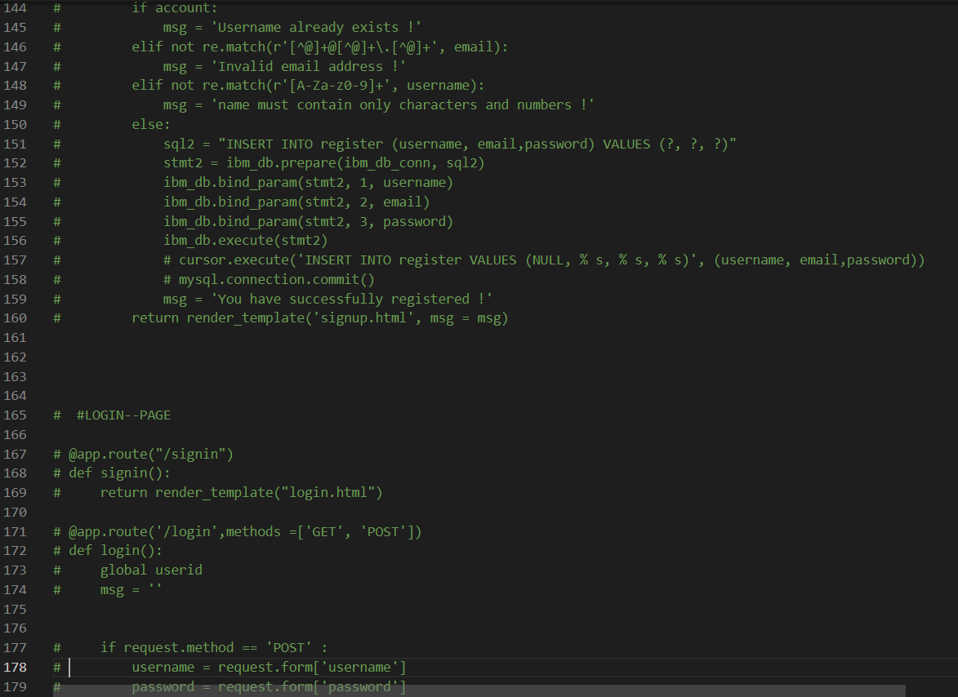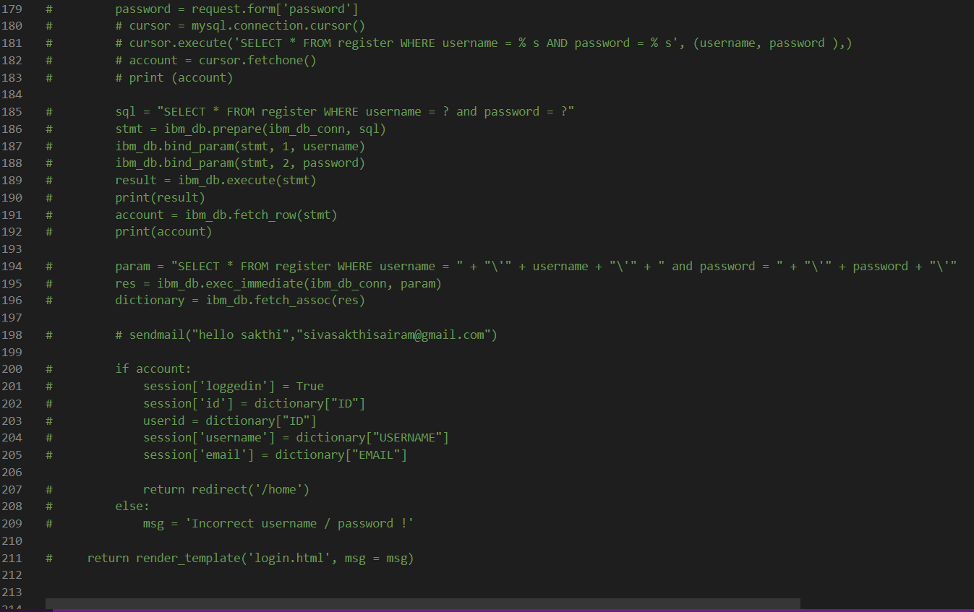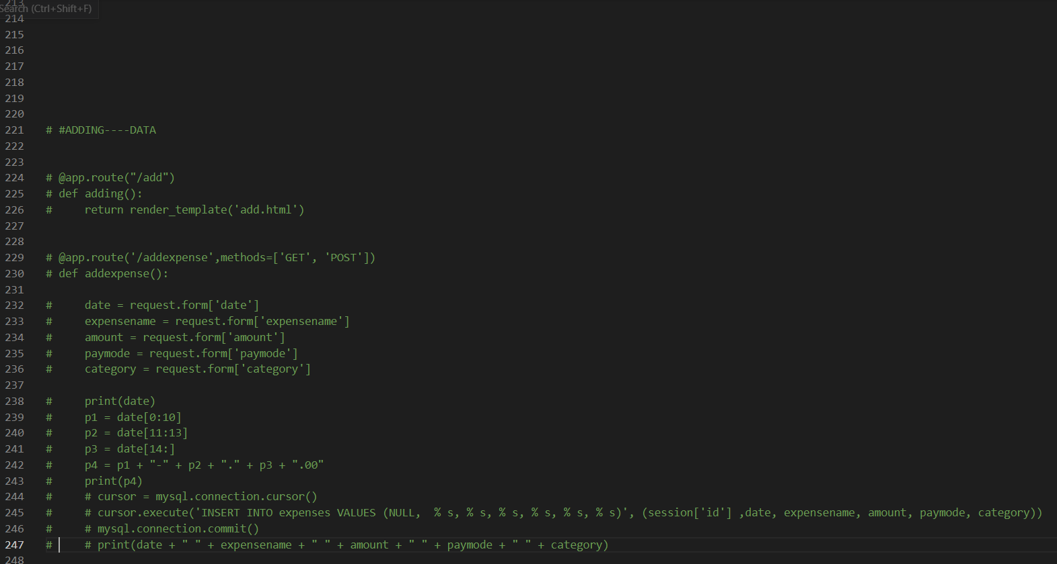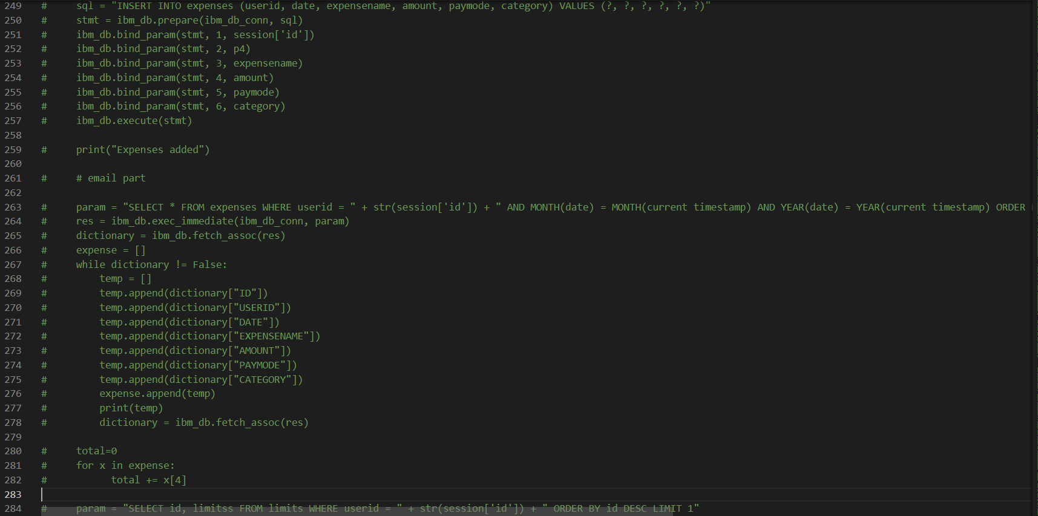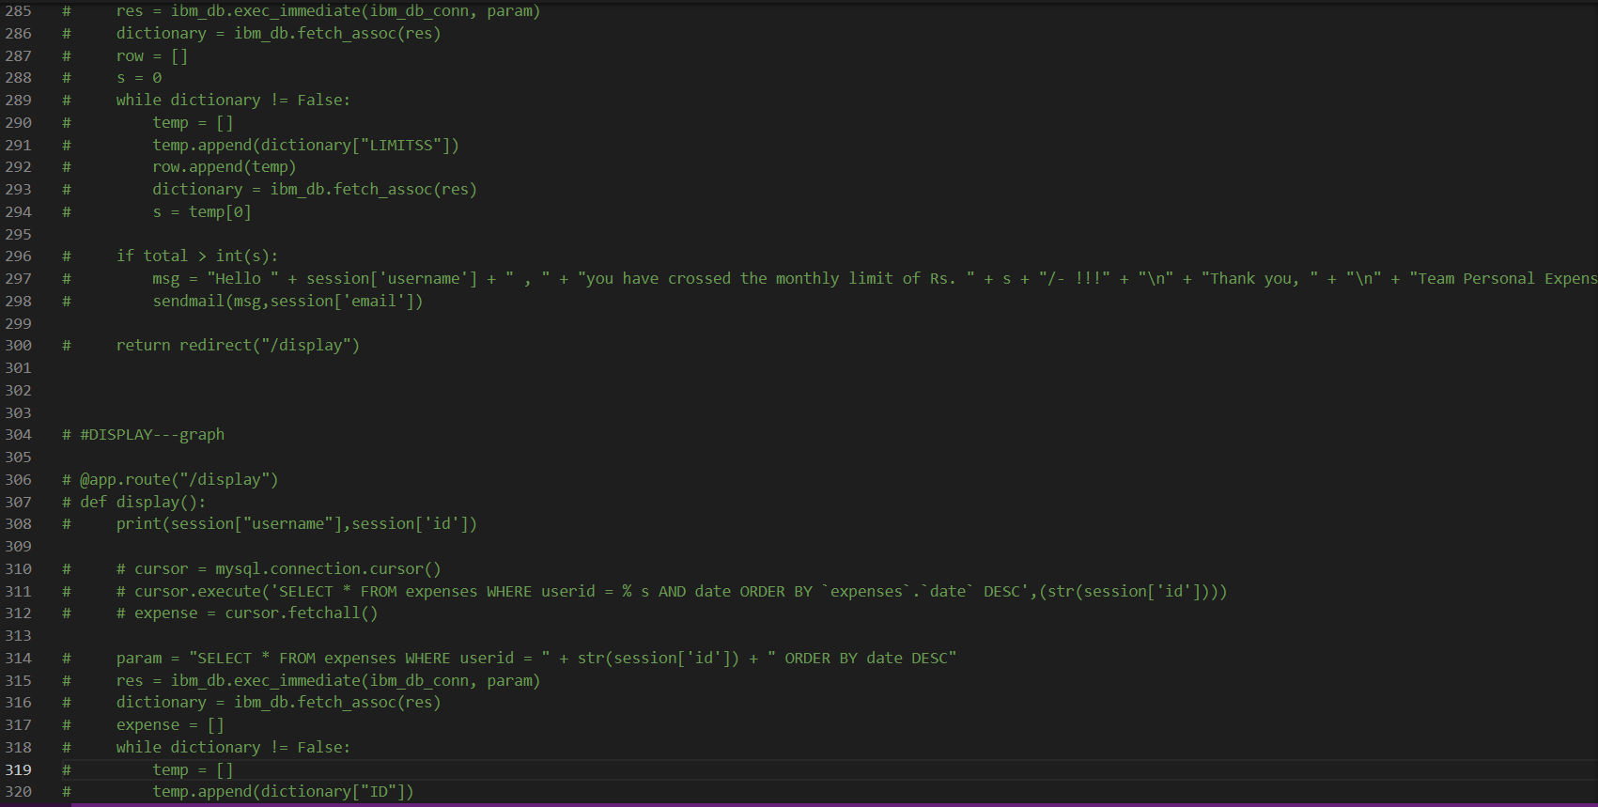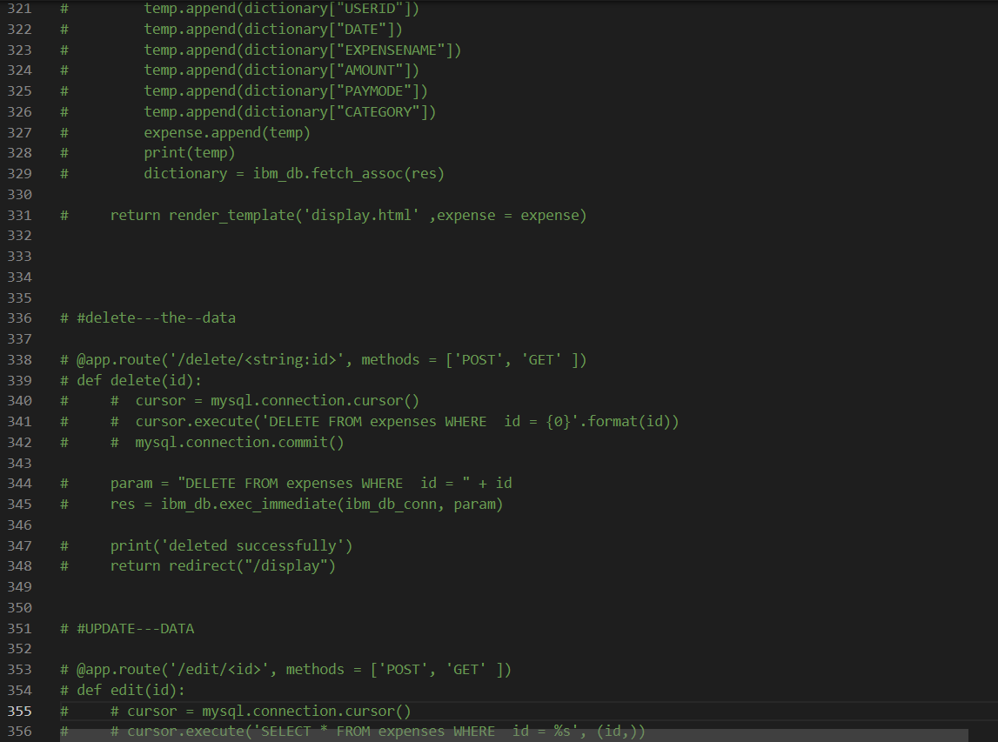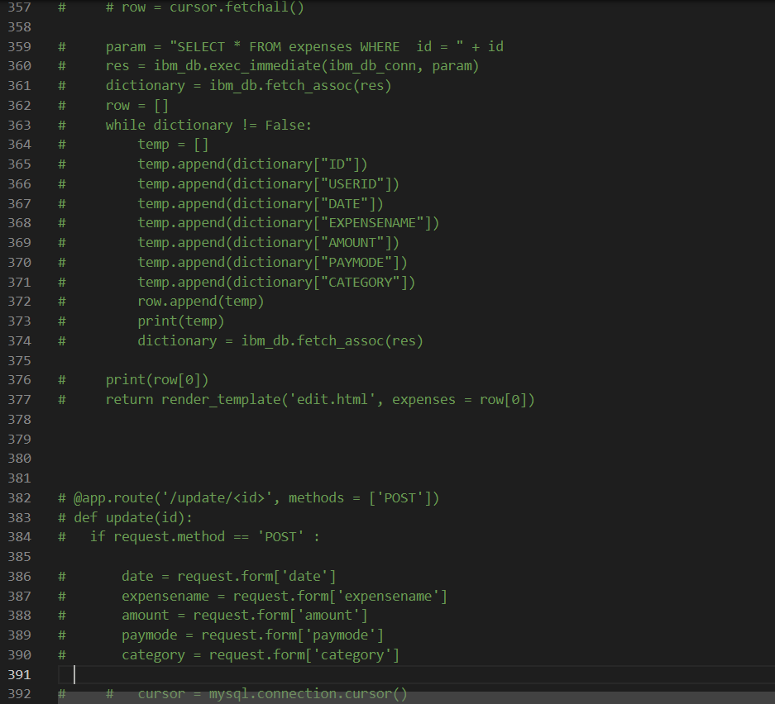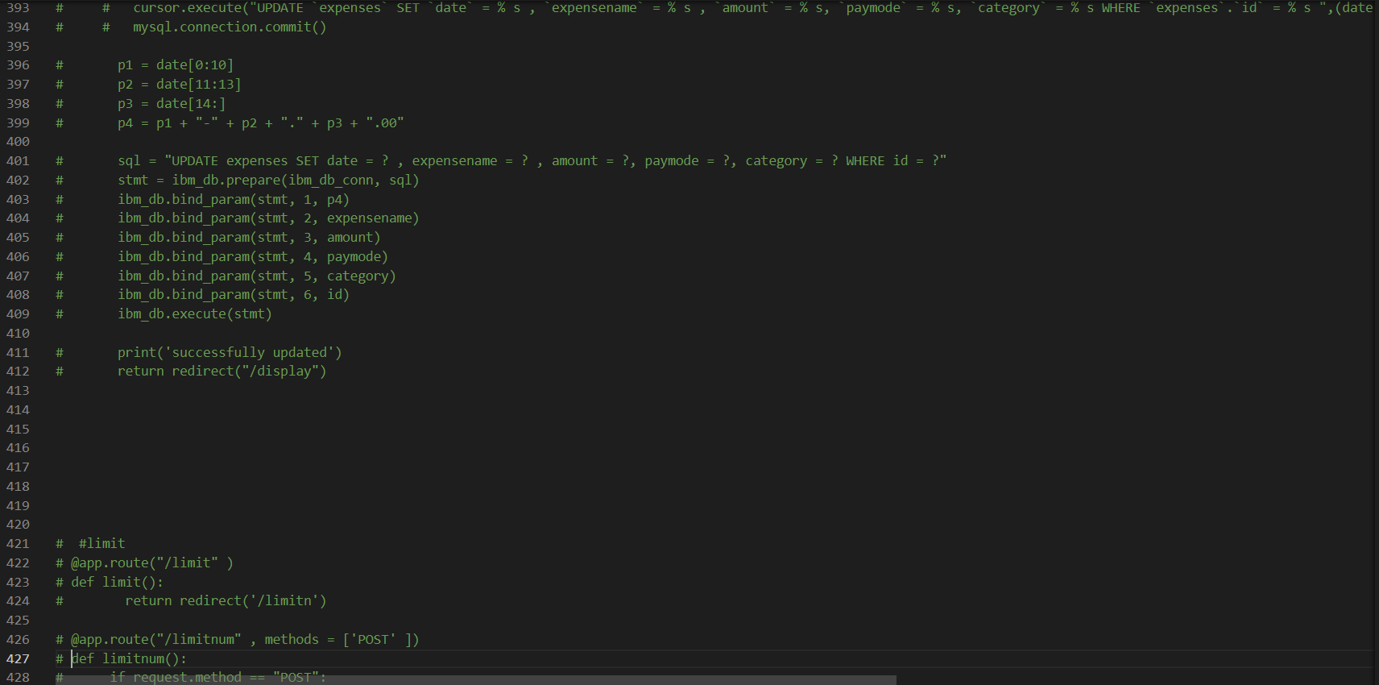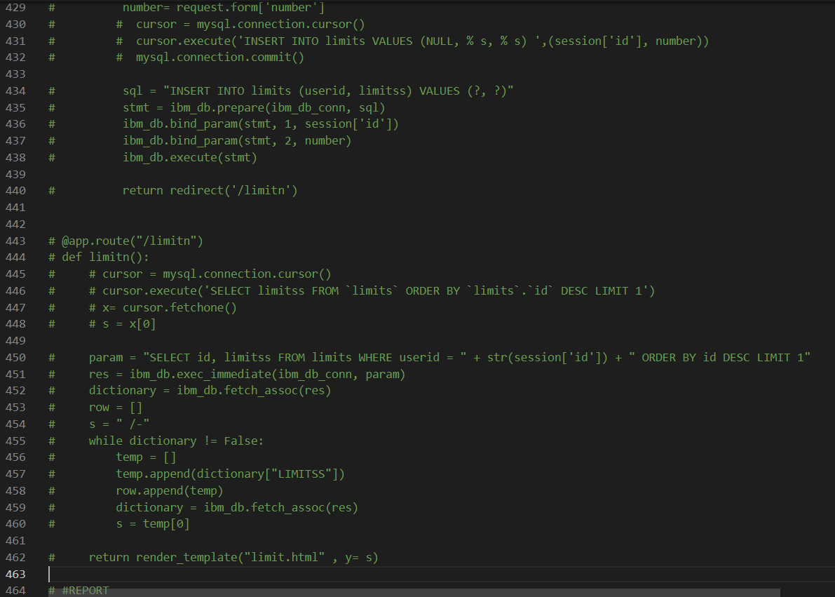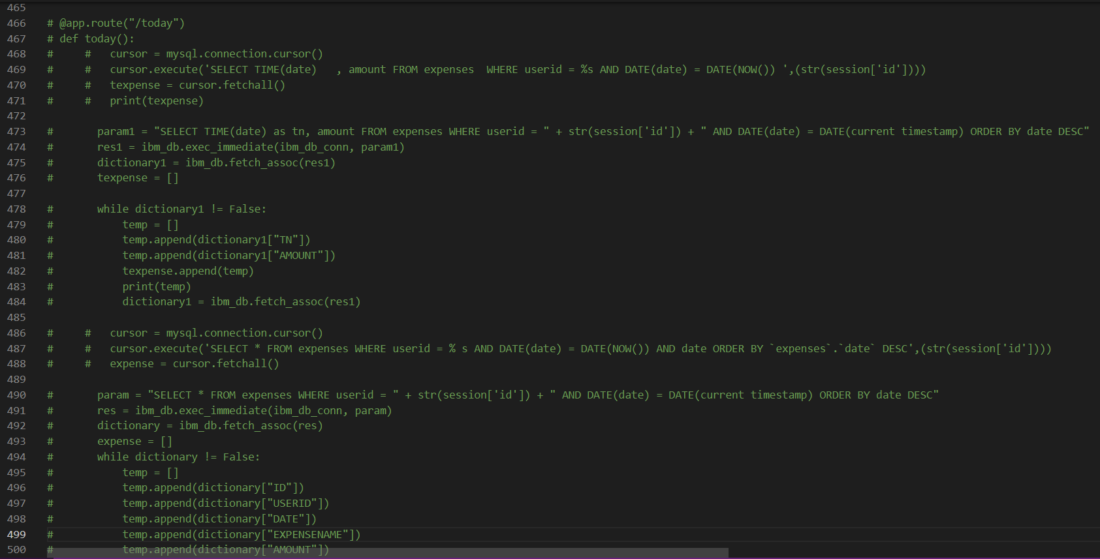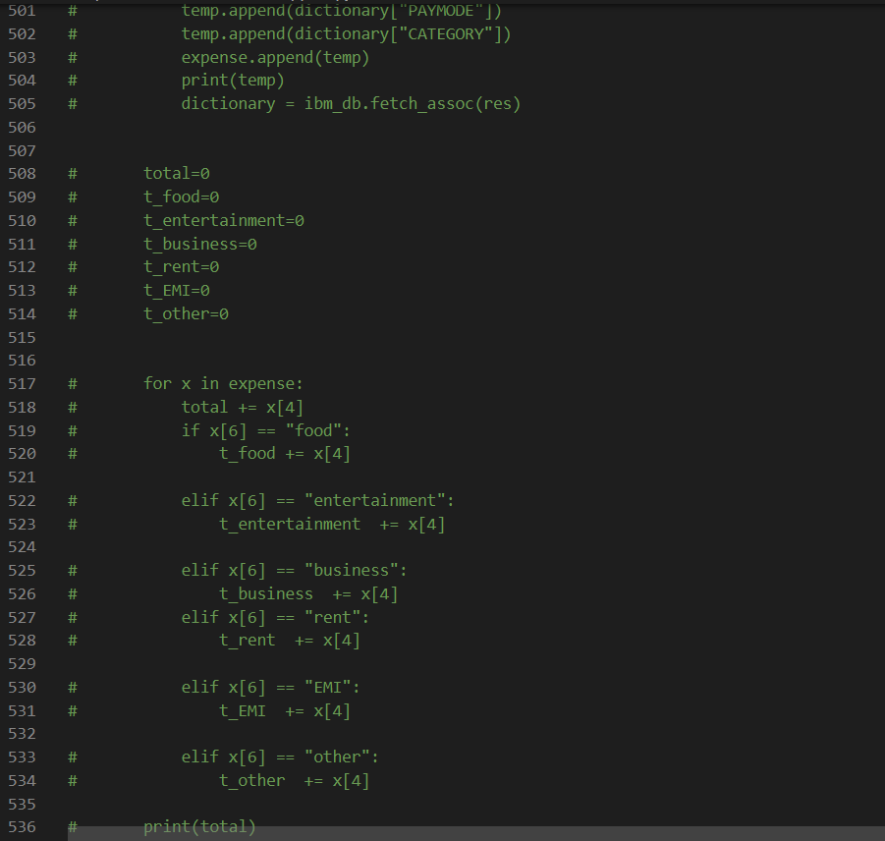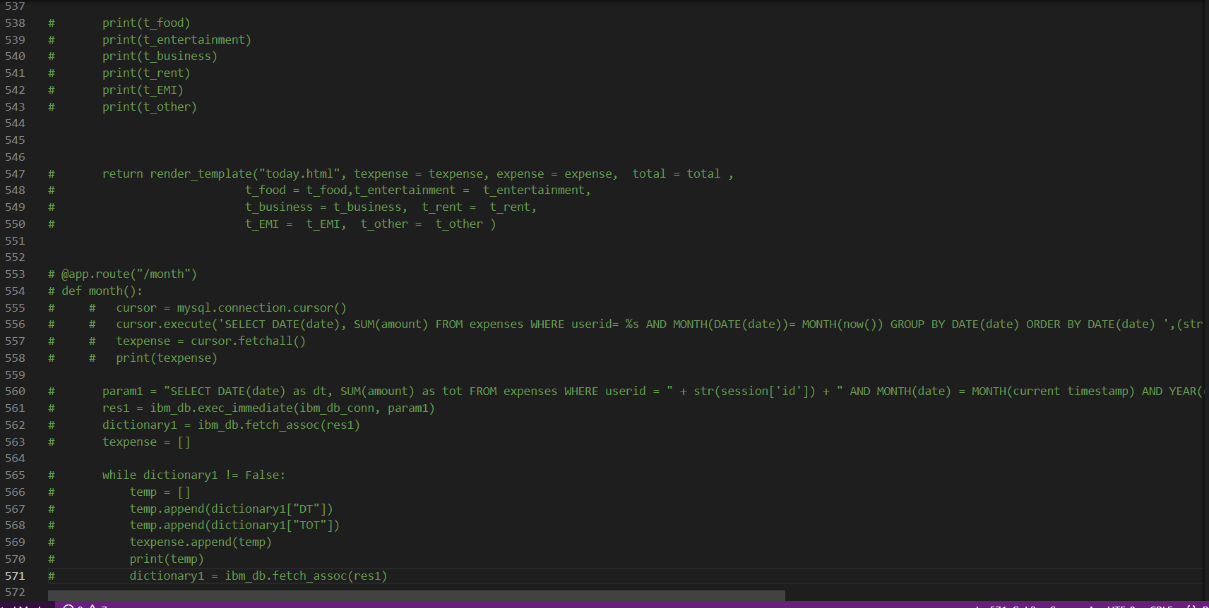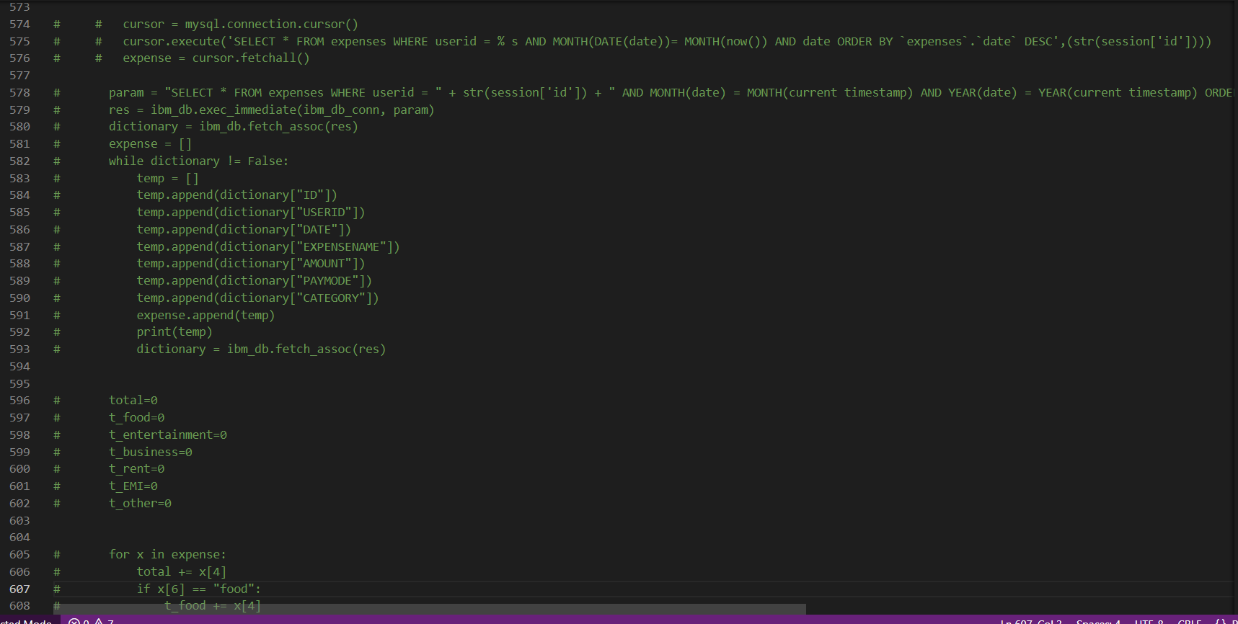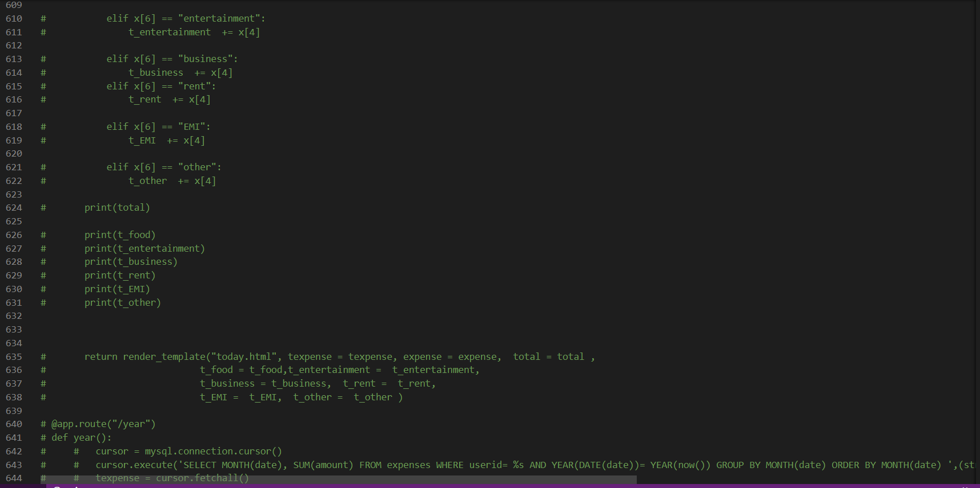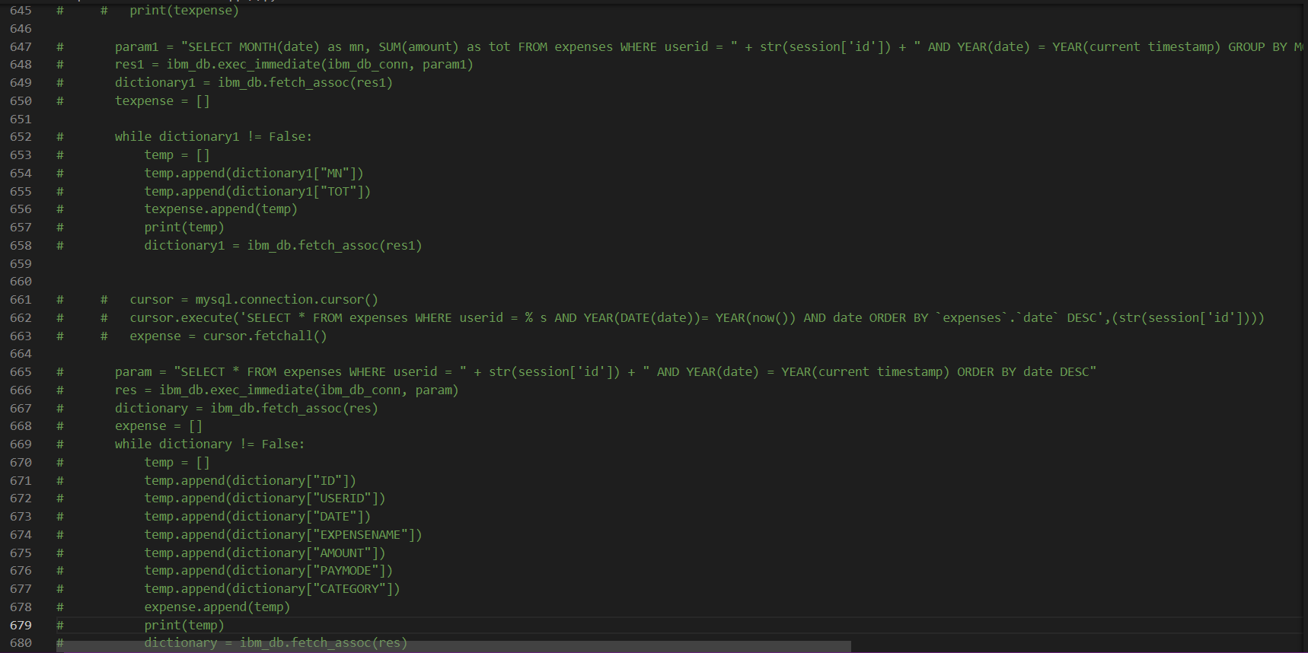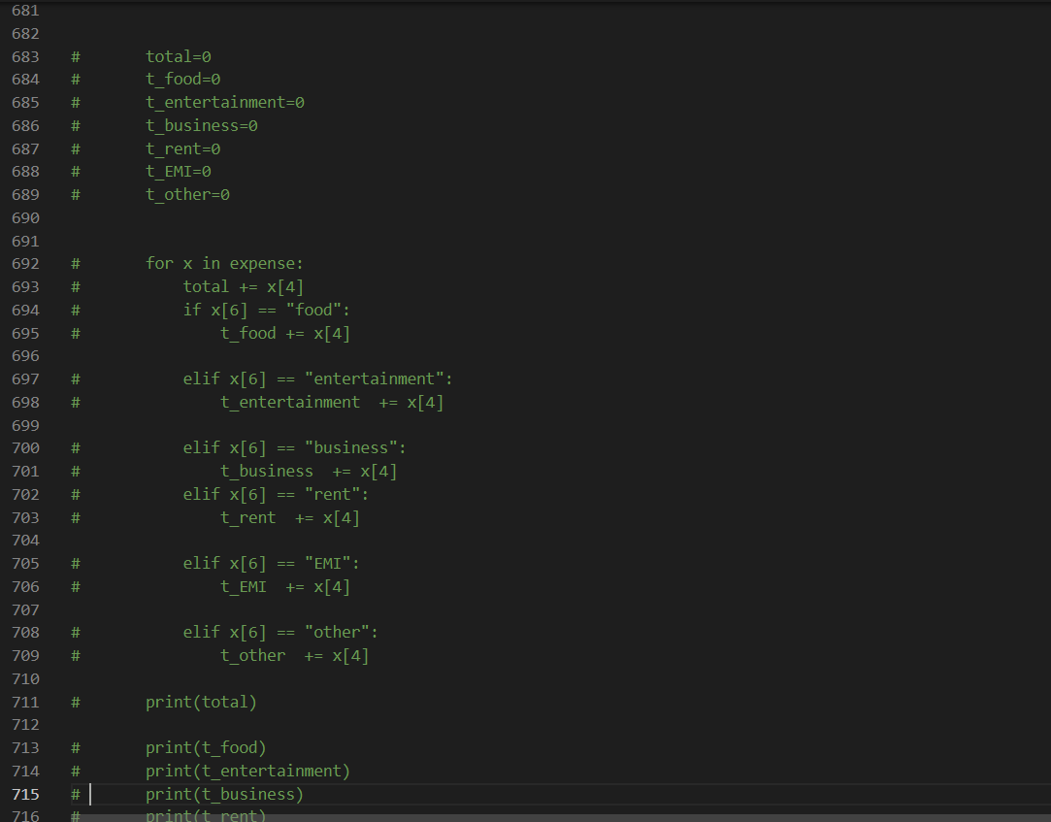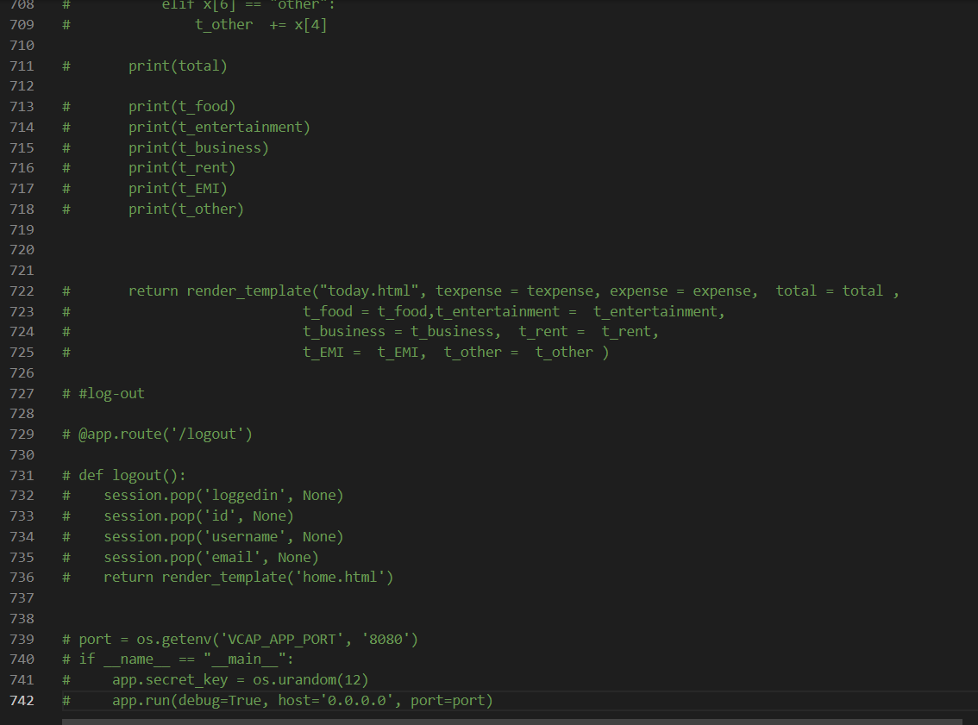

**GitHub Link:**

**https://github.com/IBM-EPBL/IBM-Project-8534-1658922460**

**Project Demo Link:**